|  |  |  |  |
| --- | --- | --- | --- |
| **Name:** | Jericho Tabingo Lagang | **Date:** | 09/26/2023 |
| **Program:** | BSCpE | **Section:** | A361 |

**Intended Learning Outcomes:**

1. Write functions to react to events.
2. Validate HTML forms.

Design a simple form that contains the following details:

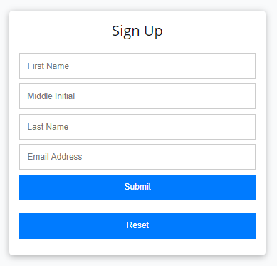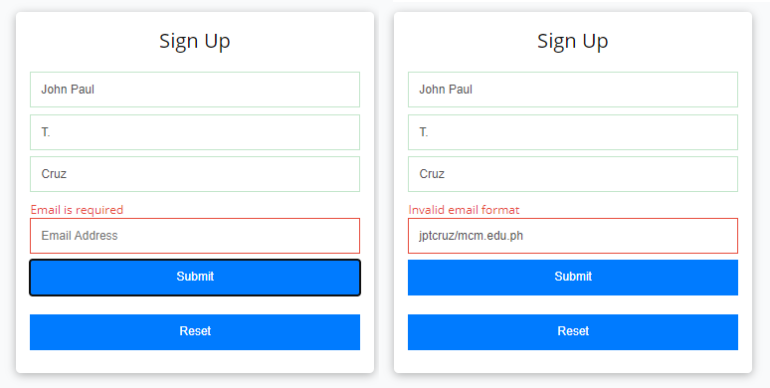

Emmy Grace

Emmy Grace

T.

T.

Requillo

Requillo

Email Address

egtolentino/mcm.edu.ph

* + First Name
  + Middle Initial
  + Last Name
  + E-Mail Address Here is an example form:

The form must be able to validate if the First Name, Middle Initial, and Last Name fields have corresponding inputs (regardless of content). The form must also validate if there is an invalid e-mail address format presented. There must be an alert message to signify that there are invalid inputs.

Here is a sample output:

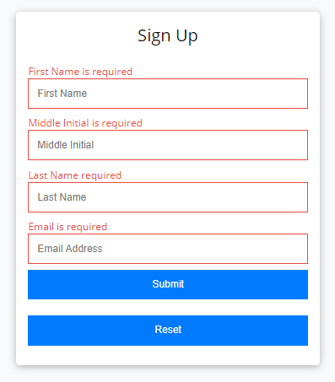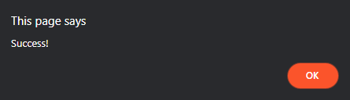

The form must be able to see if there are no inputs placed. Here is a sample output:

Once the form validates all inputs, an alert box must be seen that says **Success!**

Here is a sample output:

Emmy Grace T.

Requillo [egtolentino@mcm.edu.ph](mailto:egtolentino@mcm.edu.ph)

================================================================================

**HTML Source Code:**

<!DOCTYPE html>

<html lang="en">

<head>

<meta charset="UTF-8">

<meta name="viewport" content="width=device-width, initial-scale=1.0">

<link rel="stylesheet" type="text/css" href="form.css">

<script src="form.js"></script>

<title>Simple Form</title>

</head>

<body>

<div class="container">

<h1>Sign up</h1>

<form action="#" method="POST" onsubmit="return validateForm()">

<label for="firstName">First Name:</label>

<input type="text" id="firstName" name="firstName" required><br><br>

<label for="middleInitial">Middle Initial:</label>

<input type="text" id="middleInitial" name="middleInitial" maxlength="1"><br><br>

<label for="lastName">Last Name:</label>

<input type="text" id="lastName" name="lastName" required><br><br>

<label for="email">E-Mail Address:</label>

<input type="email" id="email" name="email" required><br><br>

<input type="submit" value="Submit">

<input type="reset" value="Reset">

</form>

</div>

</body>

</html>

**CSS Source Code:**

**body {**

**margin: 0;**

**padding: 0;**

**font-family: Arial, sans-serif;**

**display: flex;**

**justify-content: center;**

**align-items: center;**

**height: 100vh;**

**}**

**.container {**

**max-width: 400px;**

**padding: 20px 100px 20px 100px;**

**border: 1px solid #ddd;**

**background-color: #f9f9f9;**

**box-shadow: 0 4px 6px rgba(0, 0, 0, 0.1);**

**border-radius: 5px;**

**}**

**h1 {**

**text-align: center;**

**margin-bottom: 20px;**

**color: #333;**

**}**

**form {**

**margin: 0 auto;**

**padding: 0;**

**width: 100%;**

**box-sizing: border-box;**

**}**

**label {**

**display: block;**

**margin-bottom: 10px;**

**font-weight: bold;**

**color: #333;**

**}**

**input[type="text"],**

**input[type="email"] {**

**width: 100%;**

**padding: 10px;**

**margin-bottom: 15px;**

**border: 1px solid #ccc;**

**border-radius: 4px;**

**font-size: 16px;**

**}**

**.row {**

**display: flex;**

**justify-content: space-between;**

**align-items: center;**

**}**

**input[type="submit"],**

**input[type="reset"] {**

**background-color: #007bff;**

**color: #fff;**

**border: none;**

**padding: 10px 20px;**

**font-size: 16px;**

**cursor: pointer;**

**flex: 1;**

**}**

**input[type="submit"]:hover,**

**input[type="reset"]:hover {**

**background-color: #0056b3;**

**}**

**.alert {**

**color: red;**

**margin-top: 5px;**

**}**

**JavaScript Source Code:**

function validateForm() {

const firstName = document.getElementById("firstName").value;

const middleInitial = document.getElementById("middleInitial").value;

const lastName = document.getElementById("lastName").value;

const email = document.getElementById("email").value;

if (!firstName || !middleInitial || !lastName || !isValidEmail(email)) {

alert("Invalid inputs. Please check your information.");

return false;

}

return true;

}

function isValidEmail(email) {

// Basic email format validation using a regular expression

const emailPattern = /^[a-zA-Z0-9._-]+@[a-zA-Z0-9.-]+\.[a-zA-Z]{2,4}$/;

return emailPattern.test(email);

}

alert("Success!");

return true;

**Output:**

**Findings and Observations:**

Creating an HTML form with validation rules using JavaScript offers a straightforward way to enhance user input quality. By implementing validation functions, it becomes possible to ensure that required fields are filled, and data formats (like email addresses) adhere to specific patterns. Additionally, feedback mechanisms, such as alert messages, can be used to communicate validation outcomes to users. This approach significantly improves user experience and helps prevent erroneous or incomplete data submissions, ultimately enhancing the reliability of collected information.